Microfine Salt is a finely ground grade of Pure Dried Vacuum Salt. It is produced specifically for use in butter making and is finding increasing application in the production of food flavourings and other ingredients.

COMPONENT UNITS SPECIFICATION TYPICAL ANALYSIS

Sodium Chloride % m/m NaCl 99.9 min. 99.9
Surface Moisture % m/m H20 0.05 max. 0.01
Insoluble matter mg/kg <50 <10
E535, Sodium Hexacyanoferrate II mg/kg 13 7.9
Calcium mg/kg Ca <20 2.6
Magnesium mg/kg Mg <5 0.7
Sulphate mg/kg Na2SO4 <500 173
Alkalinity mg/kg Na2CO3 <150 65
Iron mg/kg Fe <5 1.5
Arsenic mg/kg As 0.3 max. <0.1
Cadmium mg/kg Cd 0.2 max. <0.01
Copper mg/kg Cu 2 max. <0.1
Lead mg/kg Pb 1 max. <0.1
Mercury mg/kg Hg 0.05 max. <0.03
Nickel mg/kg Ni 0.75 max. <0.05
Chromium mg/kg Cr 0.75 max. <0.03
Selenium mg/kg Se 2.6 max. <0.2
Antimony mg/kg Sb 2.6 max. <0.2
E551 silicon dioxide* % m/m 0.3-1.0 max 0.3**
Bulk Density* kg/m³ 560 – 720

Particle Size*
20μm % m/m through 60
30μm % m/m through 65
45μm (BS sieve number 350) % m/m through 90
63μm (BS sieve number 240) % m/m through 95
75μm (BS sieve number 200) % m/m through 98.5
90μm (BS sieve number 170) % m/m through 100
125μm (BS sieve number 120) % m/m through 100

* measured after milling and blending, all other parameters measured on Pure Dried Vacuum salt before milling.
** other levels up to 1% may be available on request.

NOTE ON SHELF LIFE
Salt is recognised as having indefinite shelf life. However, very fine salt can go lumpy in
storage, despite the addition of free-flow agents. This may cause inconsistencies in the final
products. It is recommended that Microfine Salt is used quickly, preferably within 3 months of
the production date shown on the bags. It is also advisable to avoid severe compression of
the bags, eg by prolonged double stacking of pallets.

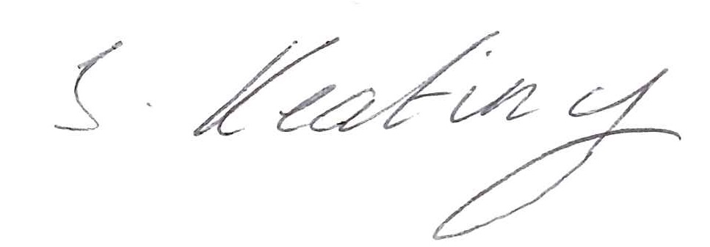
Signed: STACEY KEATING – QUALITY COORDINATOR

