Description

- A blend of salt and potassium chloride. Mainly white powder consistency with off white particles throughout.

Composition

- Sun Fine Sea Salt 80%
(contains sodium ferrocyanide – Anti-caking agent 15ppm max)
- Potassium Chloride 20%
(contains potassium ferrocyanide – Anti-caking agent 15ppm max)

Physical / Chemical / Microbiological Properties
- Free flowing dry powder.
- Mix made from raw materials not supporting the growth of microbiological organisms.

Packaging
- Blue food grade plastic bags 25kg.
- Palletised on wooden pallets and shrink wrapped.

Storage and Distribution
- Ambient

Shelf-life
- 1 year

Intended Use
- The Dry Mixes are to be used in further processing, mainly as a food ingredient.
- Product will be eaten by the general public.
- The Dry Mixes do not target vulnerable groups (allergen sensitive, infants, immune depressant, pregnant people) but vulnerable groups might still consume the food products the Dry Mixes are used within.

Origin

- Sun Fine Sea Salt - Israel.
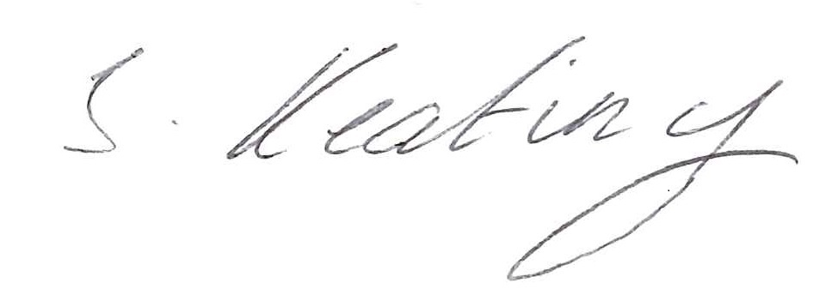
- Potassium Chloride - Israel.
- Blended and packed - UK.

Signed: Quality Coordinator.

