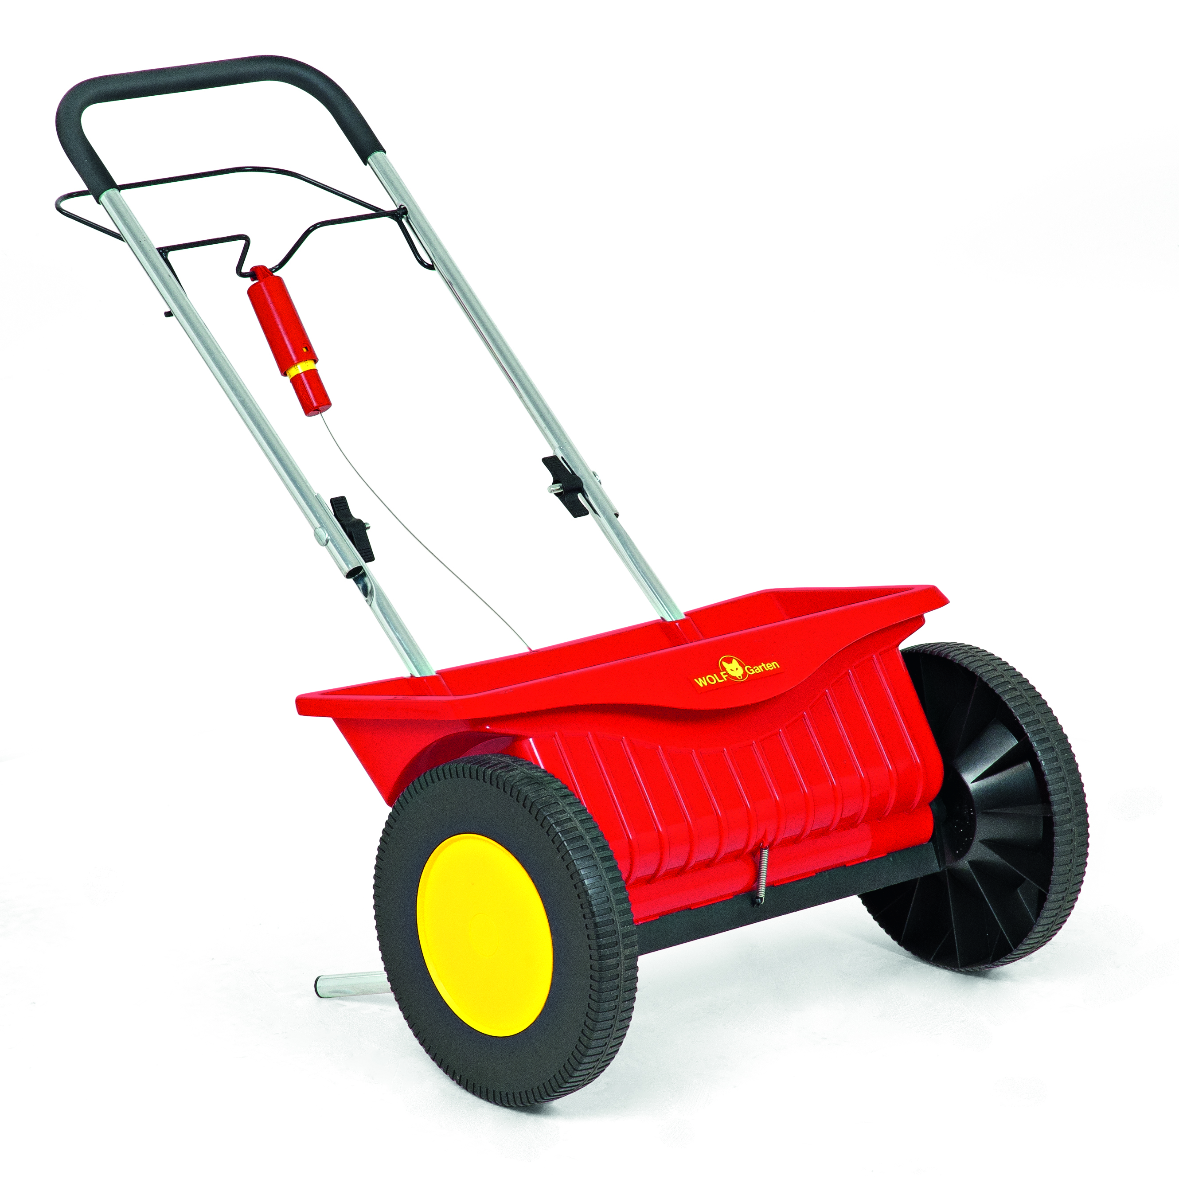
Product Name | Wolfgarten
Spreader Type | Drop (drops salt downwards)
Capacity | 20kg
Min Spread | -
Max Spread | 0.5m
Weight | 5.8kg
Assembled Dims | H 113 x W 59 D 46cm
Hopper | Plastic
Frame | Coated Steel
Wheels | Plastic
Best suited to walkways, footpaths, cycle paths and smaller open areas. Salt dispense is limited to between the wheels of the spreader, offering good controlled application
Other Data | Suitable for use with de-icing salt BS3247:1991  Adjustable Flow Rate

