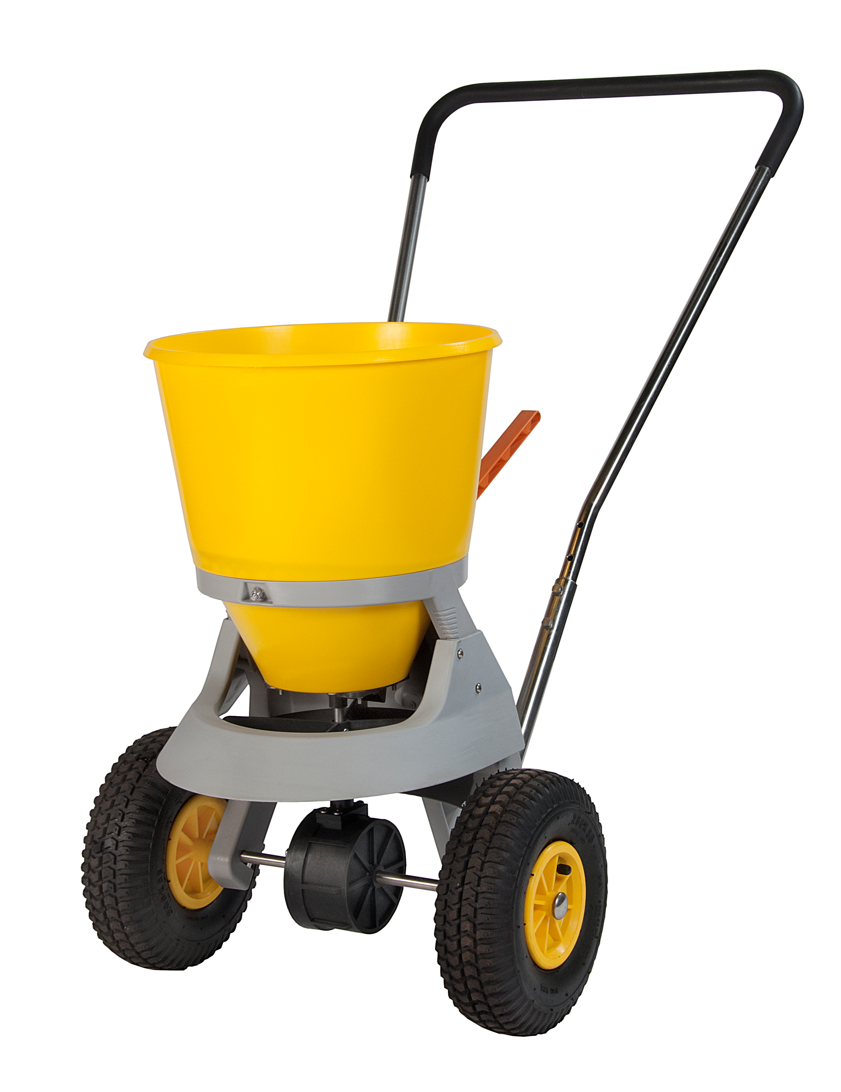

Product Name | Atlas II Composite
Spreader Type | Spinner (scatters salt outwards)
Capacity | 25kg
Min Spread | 1.0m
Max Spread | 4.0m
Weight | 10.6kg
Assembled Dims | 78x35x91cm
Hopper | Plastic
Frame | Composite Plastic
Wheels | Pneumatic
Ideal for small to medium sized playgrounds and car-parks. Can be used on driveways and wider paths. Covers a large area of ground in a single pass.
Other Data | - Suitable for use with de-icing salt BS3247:1991  - Adjustable handle height  - Robust Agitator Finger  - Adjustable Spread Rate  - Spread Guard Attached

