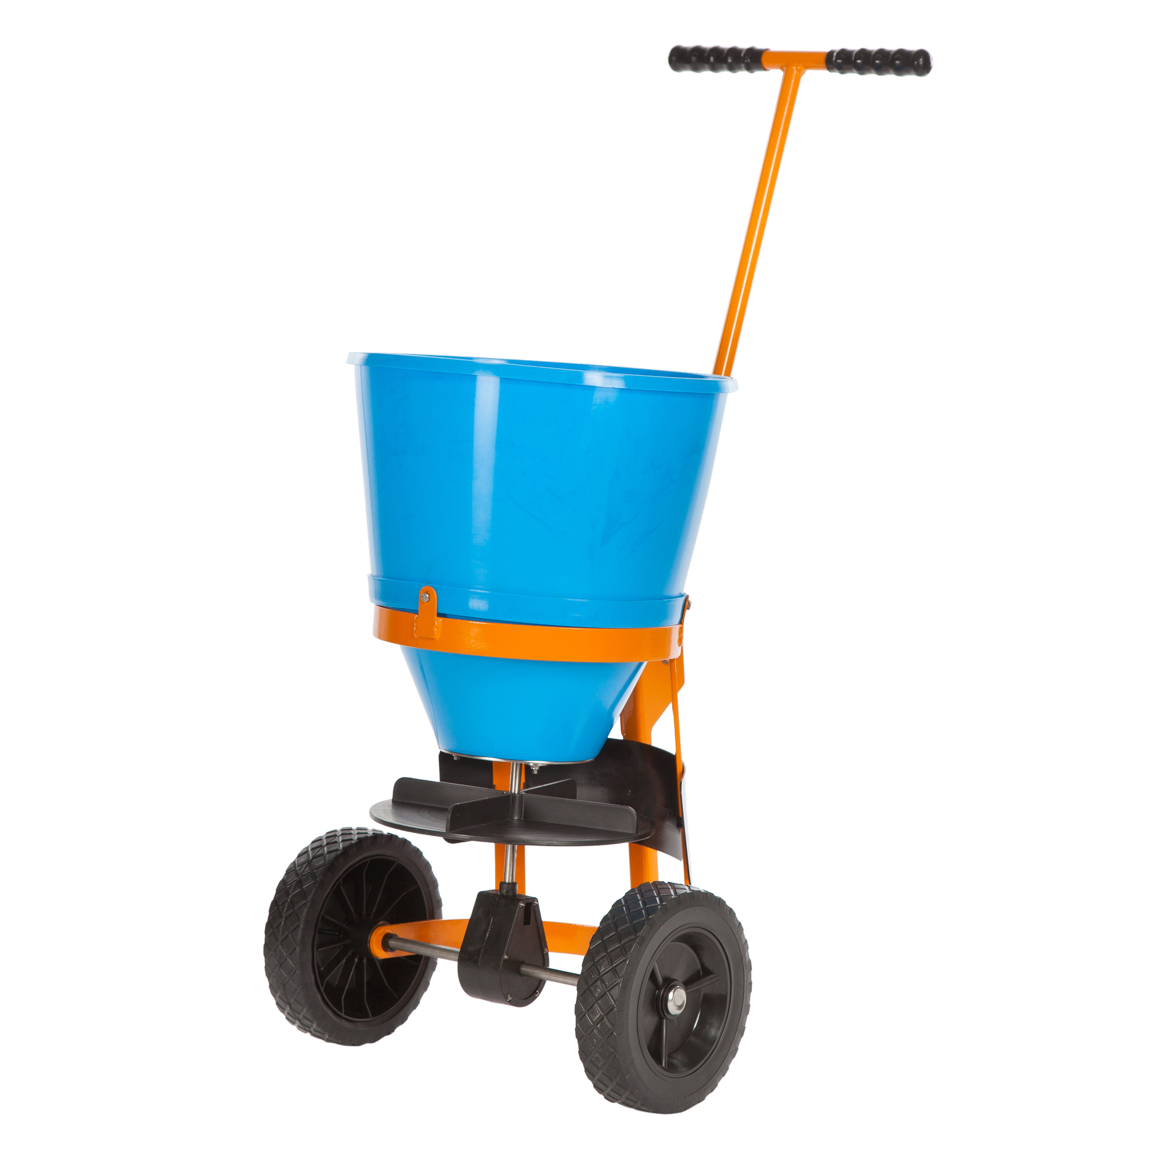

Product Name | Atlas I
Spreader Type | Spinner (scatters salt outwards)
Capacity | 25kg
Min Spread | -
Max Spread | 3.0m
Weight | 7.2kg
Assembled Dims | 60x36x81cm*
Hopper | Plastic
Frame | Coated Steel
Wheels | Plastic
Ideal for small to medium sized playgrounds and car-parks. Can be used on driveways and wider paths. Covers a large area of ground in a single pass.
Other Data | Suitable for use with de-icing salt BS3247:1991  Adjustable handle height  Adjustable Spread Rate  Robust Agitator  Spread Guard Attached

